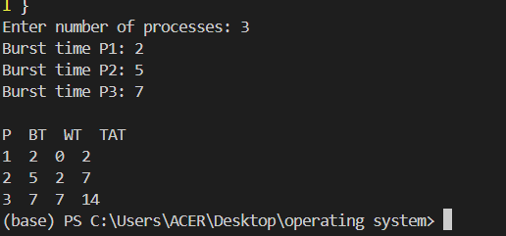 2 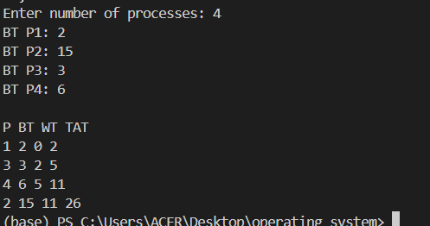
3 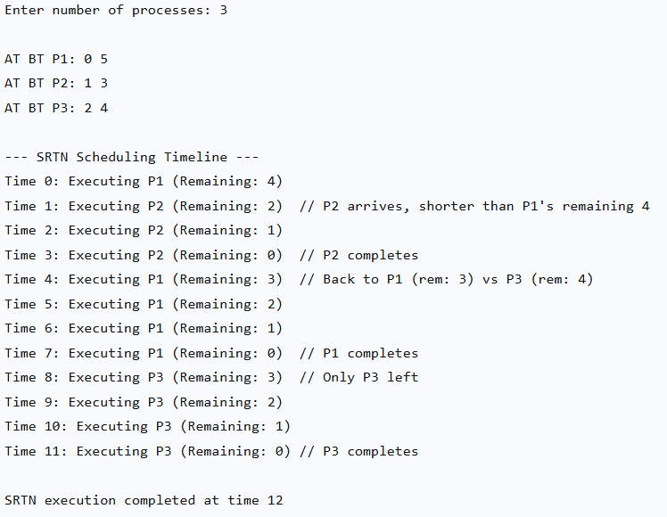
4 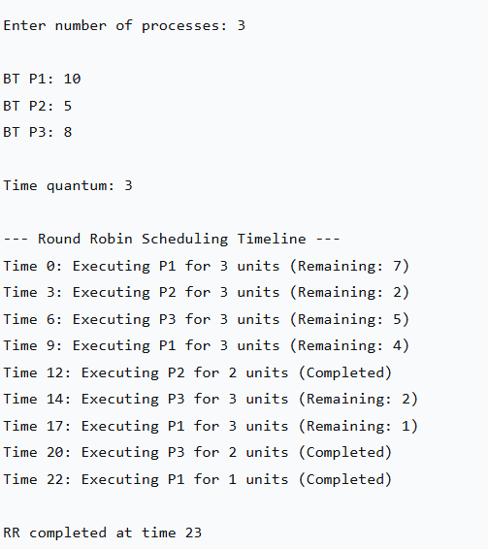5 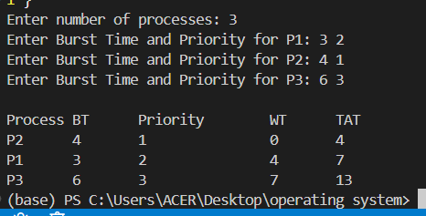
6 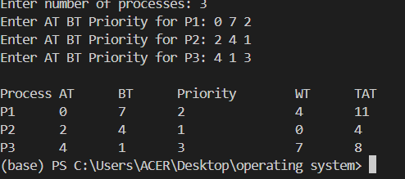

7 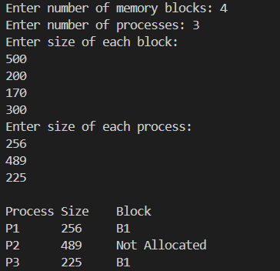 8 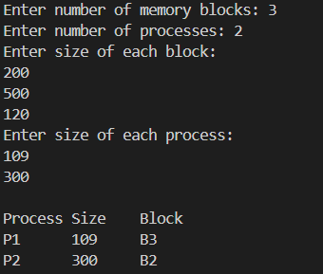
9 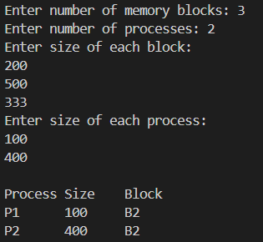 10 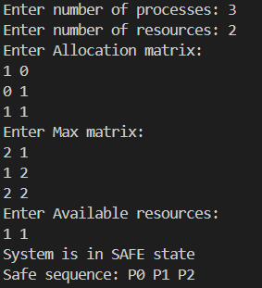11 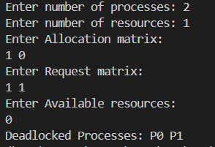
13 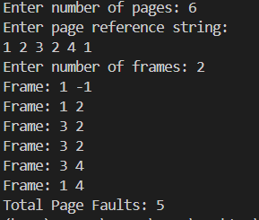 14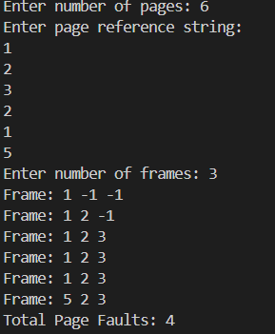
15 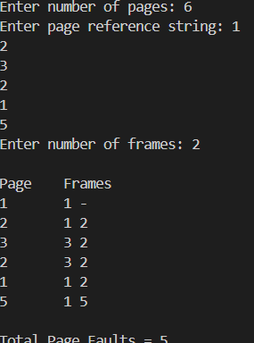 17 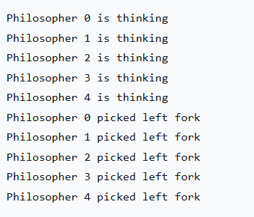
18 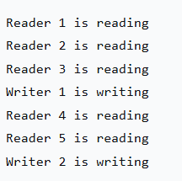 19 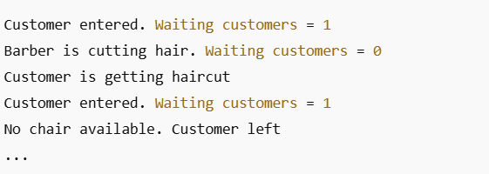
20 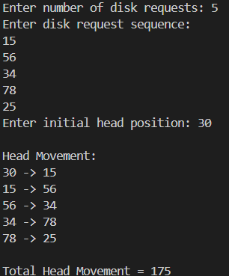 21 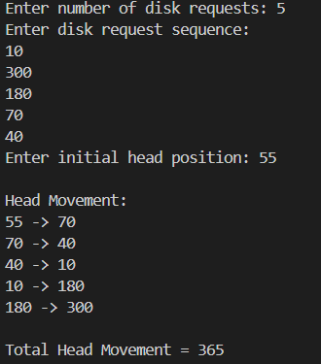 22 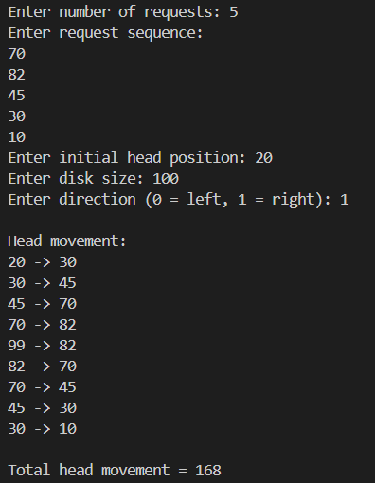
23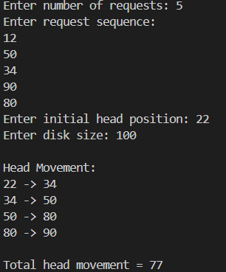 24 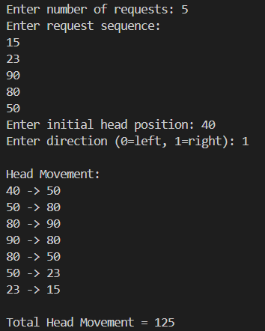 25 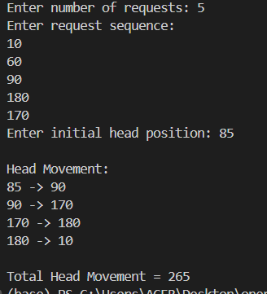

A Lab Report On
Operating system
Faculty of Humanities and Social Science
Tribhuvan University

Submitted by:
Rojip Chhantyal
Roll Number: 53002157
Southwestern State College

Submitted to:
Anupraj poudel

Department of Bachelor of Computer Application (BCA 4th Semester)
Southwestern State College
In the partial fulfilment of the requirements of the degree of Bachelor of Computer Application (BCA 4th Semester)

Basundhara, Kathmandu
TABLE OF CONTENTS

I. SCHEDULING ALGORITHMS ......................................... 1
1.1 First Come First Serve (FCFS) .......................... 1
1.2 Shortest Job First (SJF) ............................... 2
1.3 Shortest Remaining Time Next (SRTN) .................... 3
1.4 Round Robin (RR) ....................................... 4
1.5 Priority Non-preemptive ................................ 5
1.6 Priority Preemptive .................................... 6

II. MEMORY ALLOCATION ALGORITHMS .................................. 7
2.1 First Fit Algorithm .................................... 7
2.2 Best Fit Algorithm ..................................... 8
2.3 Worst Fit Algorithm .................................... 9

III. DEADLOCK ALGORITHMS .......................................... 10
3.1 Banker's Algorithm ..................................... 10
3.2 Deadlock Detection Algorithm ........................... 11
3.3 Deadlock Recovery Algorithm ............................ 12

IV. PAGE REPLACEMENT ALGORITHMS ................................. 13
4.1 First In First Out (FIFO) ............................. 13
4.2 Optimal Page Replacement ............................... 14
4.3 Least Recently Used (LRU) ............................. 15
4.4 Least Frequently Used (LFU) ............................ 16

V. IPC PROBLEMS ................................................ 17
5.1 Dining Philosophers Algorithm .......................... 17
5.2 Readers and Writers Problem Algorithm .................. 18
5.3 Sleeping Barber's Problem Algorithm .................... 19

VI. DISK SCHEDULING ALGORITHMS .................................. 20
6.1 FCFS Disk Scheduling Algorithm ......................... 20
6.2 Shortest Seek Time First (SSTF) Algorithm .............. 21
6.3 SCAN Disk Scheduling Algorithm ......................... 22
6.4 C-SCAN Disk Scheduling Algorithm ....................... 23
6.5 LOOK Disk Scheduling Algorithm ......................... 24
6.6 C-LOOK Disk Scheduling Algorithm ....................... 25

